KIDSPACE

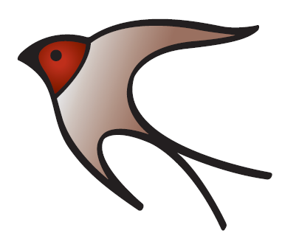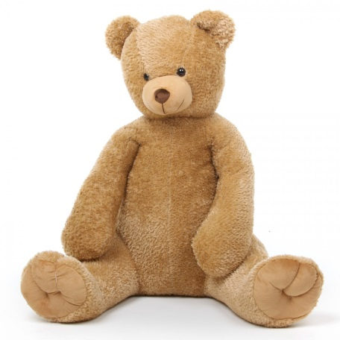

Welcome Pack

Please read this welcome pack very carefully.

This pack contains all the information you may need before sending your child to our before and after school club - KIDSPACE.

Please complete and return the:

Admissions form
Photograph Consent form
Terms and Conditions

To the school office
Thank you.

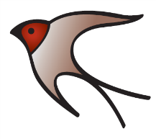 | Highfields KIDSPACE Admission form  (Please complete this form in BLOCK CAPITALS)

Details of Child:
Surname ………………………………………………………………………………………………
Forename(s) ………………………………………………………………………………………..
Known as ……………………………………………………………………………………………..
Date of Birth …………………………………………………………………………………………
Home Address ………………………………………………………………………………………
……………………………………………………………………………………..
……………………………………………………………………………………..
Postcode …………………………………………..
Email …………………………………………………………………………………………………….
Details of Parent / Carer:
First contact
Surname ………………………………………………………. Forename ………………………………..
Relationship to child …………………………………………………………………………………………
Home address (if different to child) ………………………………………………………………
……………………………………………………………………………………..
……………………………………………………………………………………..
Home telephone number ……………………………………………………………………….
Mobile number ………………………………………………………………………………………
Contact number (at work) ………………………………………………………………………

Second contact
Surname ………………………………………………………. Forename ………………………………..
Relationship to child …………………………………………………………………………………………
Home address (if different to child) ………………………………………………………………
……………………………………………………………………………………..
……………………………………………………………………………………..
Home telephone number ……………………………………………………………………….
Mobile number ………………………………………………………………………………………
Email ………………………………………………………………………………………………………….
Contact number (at work) ………………………………………………………………………

Emergency contact list:
Please list in order of preference who you would like us to ring in case of an emergency (eg: Mum, Dad, Grandma, neighbour)
- Name ………………………………………………………………………………………………
Telephone Number ………………………………………………………………………….
Relationship to child ………………………………………………………………………..

- Name ………………………………………………………………………………………………
Telephone Number ………………………………………………………………………….
Relationship to child ………………………………………………………………………..

- Name ………………………………………………………………………………………………
Telephone Number ………………………………………………………………………….
Relationship to child ………………………………………………………………………..

- Name ………………………………………………………………………………………………
Telephone Number ………………………………………………………………………….
Relationship to child ………………………………………………………………………..

People who are able to collect your child:

Name ……………………………………………………………………………………………….
Relationship ……………………………………………………………………………………..

Name ……………………………………………………………………………………………….
Relationship ……………………………………………………………………………………..

Name ……………………………………………………………………………………………….
Relationship ……………………………………………………………………………………..

Name ……………………………………………………………………………………………….
Relationship ……………………………………………………………………………………..
Please note that we will not release your child to anyone who is not on the list unless arrangements have been made with us. If the person on the list is not familiar to us we will ask for photo ID on their first collection.

In order to make safeguarding as tight as possible we also request that you choose a password. This password can be given to the people who collect your child. We may ask for the password when they collect, if they are not familiar to us.

My chosen password is ………………………………………………………………………..

Medical information:

Name of Doctor’s surgery …………………………………………………………………..
Telephone number …………………………………………………………………………….
Medical concerns/issues …………………………………………………………………………………………………………………………………………………………………………………………………………………………………………………………………………

Details of any allergies ……………………………………………………………………………………………………………………………………

In the case of a medical emergency or critical incident where we have been unable to contact you (parent), do you give authority to the school to give their consent for any medical, dental or surgical treatment, including anaesthetic or blood transfusion that is considered necessary by the medical authorities present?
Yes / No
If no, who do you nominate ………………………………………………………………….
Contact phone number ………………………………………………………………………..

Signed …………………………………………………………………………………….….(parent/carer)
Date ……………………………………………………………………
Highfields KIDSPACE
Use of Photographs / media

The club may produce printed publications and add them to the school website which may include examples of children’s work and/or photographs of children. Including images of children in club publications and on the school website can be highly motivating for children and provides a good opportunity to promote the club. However, we have a duty of care towards the children, which means that children’s photographs will not be accompanied by names.
We ask that parents’ consent to the club publishing their children’s work and to the taking and using of photographs/videos of their children subject to strict confidentiality of personal information. Your preferences can be changed at any time by contacting the club manager.

My child ______________________________________________
Please answer with a tick or cross to each question:
May we use your child’s photograph in the school prospectus and other printed publications that we produce for promotional purposes?

May we use your child’s image on our website?

May we record your child’s image on video or webcam?

Are you happy for your child to appear in the media?*

May we use your child’s photograph as part of displays around the school?

May we publish your child’s work on our website?*
Signature of authorising adult: ____________________________________ Date: ___________________
*Please note that websites can be viewed throughout the world and not just in the United Kingdom where UK law applies

Please note that you can withdraw your consent at any time. Please contact the school office if you wish to do this. This form is valid whilst your child is at Highfields Academy.

TERMS AND CONDITIONS

- GENERAL INFORMATION
- Prior to your child attending Kidspace you will be asked to complete a child’s admission form. In order for us to best meet their needs, you must disclose any relevant medical conditions affecting your child, including any dietary requirements, allergies and sensitivities and also any additional needs that your child may have.
- If at any time during the course of this agreement there is any change to your contact details you need to notify us immediately. This applies to all additional contacts that you have registered with us.
- These terms will become binding once your booked session has been confirmed. By applying for a place in any session you are agreeing to our terms and conditions.
- School policies (eg: health and safety and safeguarding/child protection will apply to the before and club also. These policies are available on the school website and from the school office.
- Anyone collecting your child must be named on the admissions form. If anyone other than those named on the form arrive to collect your child we will not release them until we have confirmed this with you.
- Whilst every reasonable care is taken we cannot be held responsible for any loss or damage to your child’s property.
- Terms and conditions may be changed by the school in order to improve our service. You will be given a minimum of one month’s notice of any changes. You may end your agreement with us by giving one month’s written notice.

- PAYMENT TERMS
- All bookings must be paid for at the time of booking. If you do not use a confirmed session, because for example your child is sick or on holiday, the session will still be paid for and no refunds will be available.
- If you fail to pay for a booked session we reserve the right to end this agreement immediately and cease providing childcare services.
- Payments are to be made via School Spider at time of booking. We accept card and Childcare Vouchers. Bookings can be amended / cancelled up to one day prior to the booked session.

- BOOKING TERMS
- If your child will not be attending a booked session for any reason you must let us know as soon as possible. Bookings can be cancelled / amended up to one day prior to the booked session.
- If a payment is overdue or outstanding, you will be unable to book any further sessions until payment has been made in full.

- CANCELLATION OF BOOKINGS
- If we are unable to provide a session which you have booked due to school closure a full refund will be made. However, we will not be liable for any other costs incurred.
- If you wish to cancel / amend a booking you can do this up to one day prior
- If a session is cancelled due to an ad-hoc school event (e.g. sporting competition) your session will be refunded

- LATE COLLECTION
- Kidspace club closes at 6.00pm. Any parent arriving after 6.00pm will be charged a late collection fee. Please see fees and charges.
- Late collection fees also apply to holiday club bookings.
- On the third instance of late collection we will have a discussion with you and we reserve the right to end this agreement immediately and cease providing childcare services.

- COMPLAINTS
Should any parent/carer wish to discuss an issue around the club they should speak in the first instance to the Kidspace Manager. If this doesn’t resolve the issue then the school’s complaints policy needs to be followed. This is available on the website and also from the school office.

- HOLIDAY CLUB
- Payment is to be made with the booking.
- If you wish to cancel a booking and give us 48 hours’ notice you will get 50% of your booking fee refunded. If the booking is cancelled with less than 48 hours’ notice you will still be liable for the full cost.

- RULES AND PROCEDURES
- Parents/carers must sign their child out of the club at the end of the session, filling in both the time and their signature.
- All children are expected to behave with safety and consideration of others in mind at all times. Any inappropriate behaviour will be discussed with parents and logged.
- Any continued disruptive behaviour may jeopardise your child’s place at the club.
- The club operates under the Golden Rules of Highfields Academy; these are explained in the school’s behaviour policy which is available on the website and from the school office.

- CONTACTING US
You can contact us by email at kidspace@highfieldsnantwich.cheshire.sch.uk or by calling the school office on 01270 814570.

Kidspace Information

Access – Breakfast club starts at 7.30am and breakfast will stop being served at 8.30am. Please use the door on the Key Stage 2 yard, there is a buzzer there.
When coming to Kidspace club children in Key Stage 1 and Years 3 and 4 are collected by club staff from their classrooms. Children in Year 5 and 6 will make their own way to the club.
When collecting your child please use the door on the Key Stage 2 yard. For safeguarding reasons it is essential that your child is signed out before you take them home.
After School clubs – If a child attends an after school activity they will be taken to the after school club by a member of staff once this activity has finished.
Evening snacks – Evening snacks will be served at approximately 4.15/4.30pm. This is not intended to be an evening meal but will be plenty to satisfy your child until they go home.
Your child’s personal belongings – We do remind all children to make sure they have all of their belongings with them when they come to the after school club. If your child realises that they have left something in their classroom or cloakroom please speak to a member of the club staff. We are not able to let pupils and parents go back to classrooms after club sessions.
Attendance and collection – If your child will not be attending the after school club for any reason it is essential that you let us know. If your child is going to be collected by someone who does not normally collect and is not recorded on your admission form you must contact the club manager. If the person is unfamiliar to us we will ask for proof of ID and your personal password before releasing your child. If your child is sick whilst attending the club we will contact you to collect them. Please ensure that all contact details are kept up to date. If you have not collected your child by 6pm then you will need to collect them from the main entrance to the school.
Activities – During breakfast club we provide breakfast and aim to provide a calm and relaxed atmosphere for children to chat and play before beginning their school day. In after school club we offer a range of activities such as sports, arts and crafts, board games, puzzles, toys, role play activities, space for relaxed reading, and sometimes computer games / films. Children will have access to outdoor activities every day (weather depending) and if we have any special events planned you will be given as much notice as possible. If the weather is poor the children will also have access to the school hall on evenings when it is not being used for other school activities.

Fees and Charges
- Breakfast Club (7.30am to 8.50am) in term time - £5.50 per session
- After school club (3.30pm to 6.00pm) in term time - £10.00 per session
- Late Charges - If a pupil is collected late from a session the charge will be £10 for the first 15 minutes and an additional charge of £10 for every 10 minutes after that time.
Payment
Payment can be made by:
School Spider by card or Childcare Vouchers
Ofsted No: 143160
Ways you can contact us –
Email: kidspace@highfieldsnantwich.cheshire.sch.uk
School: 01270 814570

