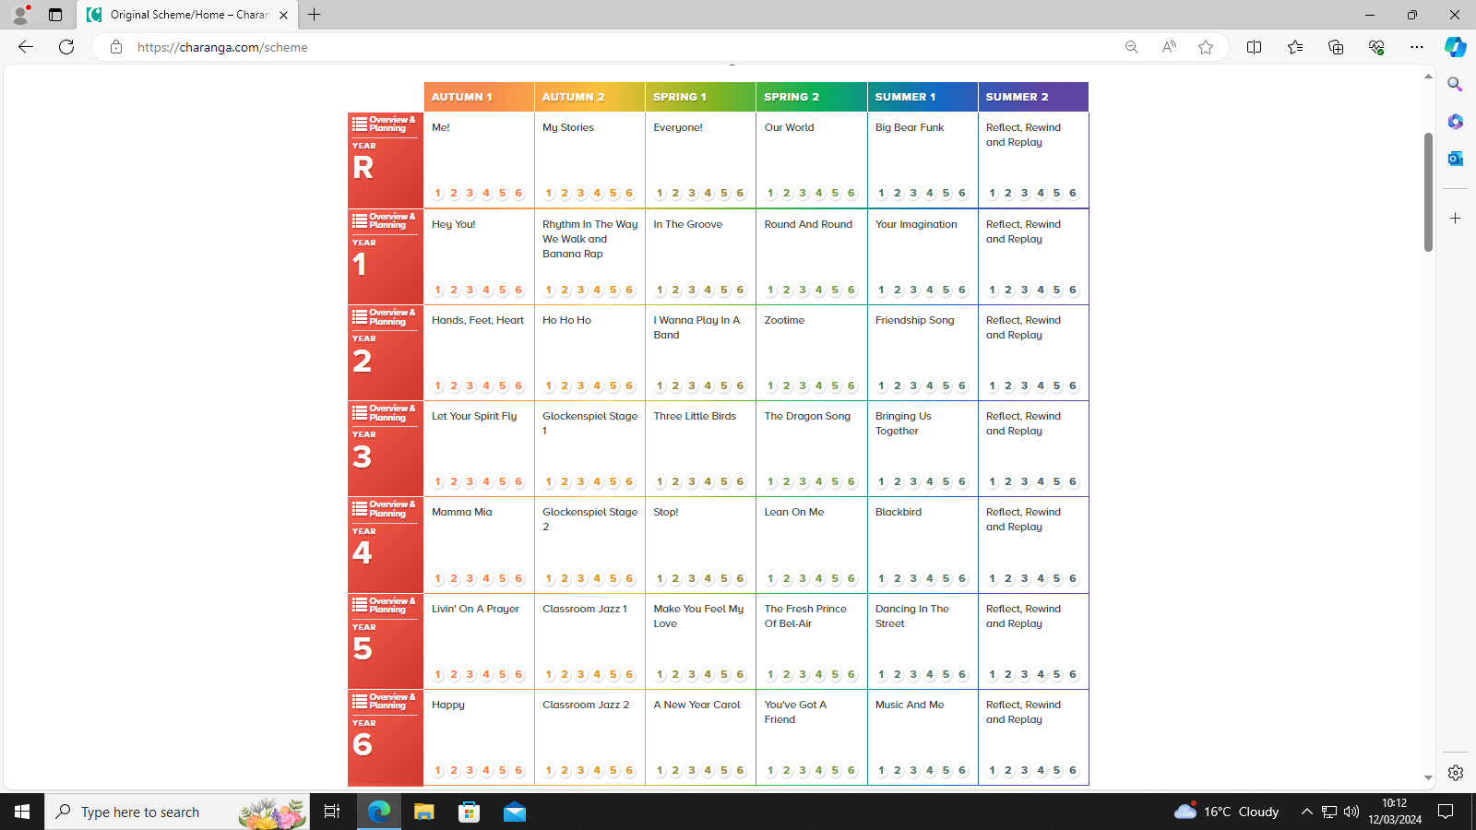

This document shows the themes that are used in our Charanga lessons.