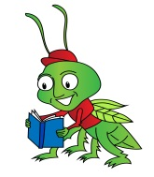 Little Crickets Pre School

8th December 2021

Dear Parents/Carers

As always, our Little Crickets are busy during this festive season.

As we need to stay close to home this year we have decided to have ‘Little Crickets Mini Christmas Market ‘on Friday 10th December 21 at 3.30pm.

All proceeds from this event will be given to the MacMillan Cancer Support to do our bit to support this special charity for the work that they do at Christmas and throughout the year.

Our stall will have something for everyone from baked goods from our fabulous Highfields kitchen, lucky bags, crocheted items, homemade crafts, tree decorations and we have not forgotten Rudolph.
We will be selling bags of ‘Rudolph’s Special Supper’ to make sure he has the energy for the busy Christmas Eve ahead.

With items ranging from 20p up to £2.00 there will be lots to choose from!

We hope to see you there

Many thanks

All at Little Crickets

