Pupil Premium Funding 2023-24

What’s the purpose of pupil premium funding?

Publicly-funded schools in England get extra funding from the government to help them improve the attainment of their disadvantaged pupils. The pupil premium grant is designed to allow schools to help disadvantaged pupils by improving their progress and academic outcomes.

Schools decide which ways of spending this money would have the greatest impact on removing barriers to learning and supporting these groups. The school Governors challenge the school to ensure we use the money to the best advantage of these children and an allocated Governor evaluates the work being undertaken and its impact. The school may use the funding on whole school initiatives, targeted interventions or wider support.
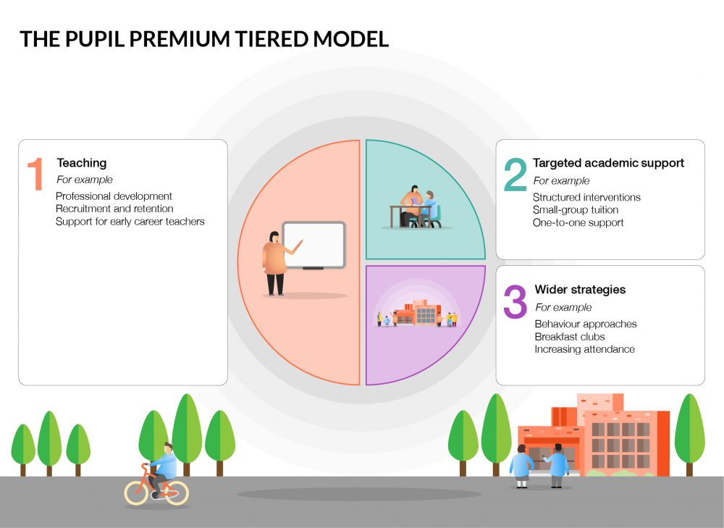

How much money does the school get?
Schools get pupil premium funding based on the number of pupils they have in January each year from the following groups.
- Benefits Related Free School Meals

Schools get £1,345 for every primary age pupil who claims free school meals, or who has claimed free school meals in the last 6 years.

Your child/ren is eligible if you receive any of the following benefits:
- Universal credit (provided you have a net income of £7400 or less)
- Income support
- Income-based jobseekers’ allowance
- Income-related employment and support allowance
- Support under Part IV of the Immigration and Asylum Act 1999
- The guaranteed element of state pension credit
- Child tax credit, provided that you are not also entitled to working tax credit and have an annual gross income of £16,190 or less

Looked-after and previously looked after children
Schools get £2,345 for every pupil who has left local authority care through adoption, a special guardianship order or child arrangements order.
Local authorities get the same amount for each child they are looking after; they must work with the school to decide how the money is used to support the child’s Personal Education Plan.

Service Premium
The service premium is not part of the pupil premium as the rules to attract the service premium are different.
Schools get £310 for every pupil with a parent who:
- is serving in HM Forces
- has retired on a pension from the Ministry of Defence
This funding is to help with pastoral support.

Academically Able Children
The pupil premium is not based on ability. Research shows that the most academically able pupils from disadvantaged backgrounds are most at risk of underperforming. Schools should focus on these pupils just as much as pupils with low results.

Pupil Premium benefits at Highfields Academy

Apart from Quality First Teaching and targeted classroom support, a child in receipt of Pupil Premium Funding may also be able to access some of the following:

- Free music tuition –piano, keyboards, drums or guitar.
- Free breakfast at the Morning Club (before school club run by teaching staff)
- Discounted educational and residential visits.
- Nurture support from our Pupil Premium teacher.
- A Pupil Premium starter pack – contains items of school uniform and stationary.

This provision is something we have decided to offer our families at Highfields Academy in addition to bespoke educational support. This may not be indicative of what other schools may offer.

How to apply
If your child is in the infants and receives a universal free school meal, you may still be eligible to be registered with the local authority for an income related free school meal. You can check if this is applicable by visiting the Cheshire East website
http://www.cheshireeast.gov.uk/schools/free school meals.aspx for more information. You need to be registered with the local authority in order to receive Pupil Premium Funding.

If you think your child is eligible or have any questions about Pupil Premium Funding please do not hesitate to contact the school.

Pupil Premium Lead – Mr A Strefford (deputy@highfieldsnantwich.cheshire.sch.uk)

