Science Knowledge and Skills Coverage. (EYFS)
Content/  Knowledge | Colour  -I can explore the world around me, making observations of colour.  -I can participate in discussions and offer my own ideas using scientific words  -I can understand some important processes and changes in the world, including colour and how they change by mixing. |  |  | All About Me  -Explore the world around them, making observations and drawing pictures of themselves and others.  -Know similarities and differences between the natural world around them.  -Work and play cooperatively and take turns with others. |  | Celebrations  I can explore the world around me, making observations of colour.  I can participate in discussions and offer my own ideas using scientific words.  I understand some important processes and changes in the world, including colour and how they change by mixing. |  |  |  | Traditional Tales  Speaking - Offer explanations for why things might happen, making use of recently introduced vocabulary from stories.  Natural World -Understand some important processes and changes in the natural world around them, drawing on their experiences of what has been read in class.  Speaking – offer explanations for why things might happen, making use of recently introduced vocabulary from stories when appropriate.
Book/ Science Capital | 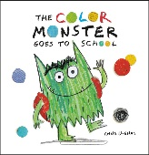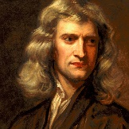 |  |  | 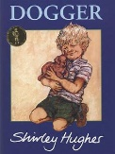  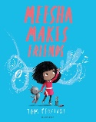  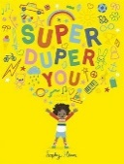 |  | 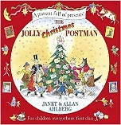  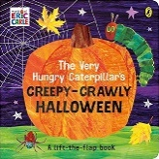  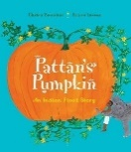 |  |  |  | 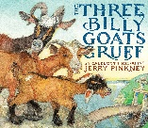  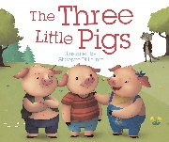  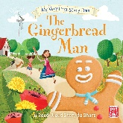
Scientific Enquiry |  |  | Look for patterns when colour mixing  Observation over time colour change.  Colour absorbency over time. |  | Identify parts of the body  Look for patterns  Identify Senses. |  | Identify shapes and features of a spider.  Look for simple patterns.  Patterns |  | Observe over time  Comparative test  Comparative test |  | Identify different liquids and materials  Simple test  Simple test
Working Scientifically |  | Ask how and why questions  Show curiosity and question why things happen.  Observe and describe what they see using everyday language. |  |  | Observe parts of the body  Explain ideas clearly.  Record learning in a table. |  | Observe features of a spider.  Explain ideas  Planning simple test |  | Predict what will happen.  Evaluate snow  Record results in a simple bar chart. |  | Make careful observations  Ask and answer simple questions.  Plan simple tests.
Ideas/WOW moments. | - Read Colour monster book.  Explore and experiment with colour paddles, equipment and torches.  Make colour spinner (Newton)  2. Look at colour images, look through rainbow glasses.  Bicarb and paint experiment of changing colour. Skittles activity, feely bag, Dark den, paint mixing.  3. Colour mixing using diffusion, colour in nature walk, colour mixing in bags. |  |  | - Point to parts of the body.  Draw parts of the body in a mirror.  Through a box lid  Make own face- where do features go?  Label body  Find body parts in gloop  2. Order stages of growth  Role play corner  Set out areas with the above stations)  3. Identify body parts  Identify senses  Play keeper of the keys  Food tasting  Feely bags  Instruments |  | - Zoom in image of spider- curiosity  Spider making web  Spider search outdoors  Make spider web to stick flies to.  Label spider and make own spider.  2. jelly worms in lemonade activity  Creepy crawly hunt  Potion station  Bug classification and obs drawings.  Witches cauldron an potions.  3. Ice hands and melting  4. Candy canes in bicarb experiment  Label reindeer  Ice sensory play  Santas workshop play corner  Snow scene.  5. Make own snow  6. Which chocolate is the stretchiest? |  |  |  | - Read gingerbread man  Test what happens if gingerbread man gets wet?  Make a raft using junk materials  Make umbrella or roof  Playdough gingerbread men.  Retell story using small play. Make bridges out of bricks.  2. Read Three Little Pigs  Materials test  Make houses out of different materials.  Make a maze with Lego.  Make an outside maze.  3. Read Billy Goat Gruff  Make a raft  Make a bridge- junk  Outside bridges
Outcomes | To name different colours  To explore mixing colours  To explore rainbows  To explore shadows. |  |  | To name basic body parts  To know that we look different as we get older.  To describe people who are familiar to them  To know how to take care of themselves.  To understand some of their senses. |  | Can name and describe animals that live in different habitats  Can talk about what the see and give basic reasons.  Can look carefully and draw basic body parts of animals and mini-beasts.  Can make basic predictions. |  |  |  | Can name the materials they are using and why.  Can talk about the basic properties of materials and why it is suited for a purpose.  Can observe changes in their natural world and say why it is different now or will change in the future  Can compare and describe how materials change over time. .

Content/  Knowledge | Animals  I can understand the similarities and differences of animals in this country and in other countries.  I can recognise some environments that are different to the one in which they live.  I can understand the effect of changing seasons on the natural world.  I can engage in non-fiction books.  I can revise and refine my fundamental movement skills. |  | Under the Sea  Explore the natural world around them, making observations and drawing pictures of animals and plants.  I can identify animal habitats.  I can group fish based on my observations  I can make observations of the natural world.  Understand some important processes and changes in the natural world around them, including the seasons and changing states of matter.  I understand why things float or sink  Know some similarities and differences between the natural world around them and contrasting environments, drawing on their experiences and what has been read in class.  I can make observations of plants and animals |  | Minibeasts and growing  I can understand important changes and processes in the natural world.  I can explore the natural world around me.  Safely use and explore a variety of materials, tools and techniques, experimenting with colour, design, texture, form and function. |  | Keeping Healthy  I can manage my own basic hygiene and personal needs, including dressing, going to the toilet and understanding the importance of healthy food choices.  I can show sensitivity to their own and to others’ needs.
Book/ Science Capital | 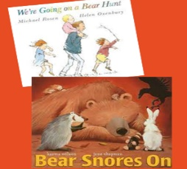  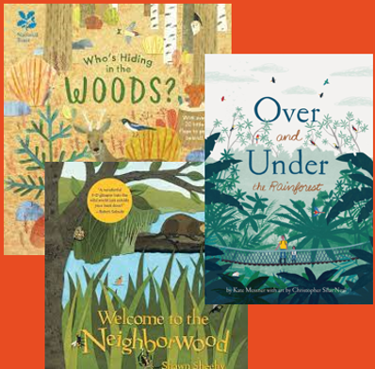 |  | 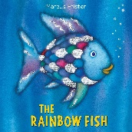 |  | 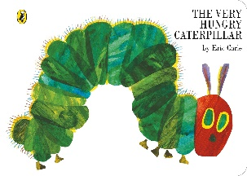 |  | 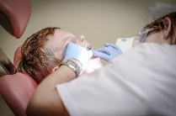  Dentist
Scientific Enquiry |  | Identify where animals may live in the world.  I can look for patterns between the animal and its environment.  I can observe what happens to the temperature over time with and without insulation.  I can research facts about a chosen animal.  I can identify different animals and use observations to move like different animals. |  | I can identify animal habitats  I can identify the parts of a fish.  I carry out a comparative test.  I can identify patterns.  I can find out about what a deep sea-ecologist does. |  | I can identify the stages of a caterpillar  I can observe my plant growing over time.  I can use research to identify insects.  I can identify parts of a minibeast.  I can notice changes  I can observe my habitat over time. |  | I can identify different ways to keep myself healthy  I can observe how germs spread over time.  I can identify simple patterns.  I can identify different emotions.
Working Scientifically |  | Notice similarities and differences within the seasons.  I can make sensible predictions about where animals may live.  I can explain in simple terms how animals adapt to their habitat.  I can ask questions to help research facts about an animal.  I can apply my knowledge of animals through movement. |  | I can ask simple questions  I can group using my observation skills.  I can make simple predictions.  I can draw pictures using my observation skills.  I can make careful observations. |  | I can make careful observations.  I can test out my ideas.  I can record my findings.  I can interpret my findings using a model.  I can record using my chosen method.  I can talk about my learning when creating my habitat. |  | I can record ways to keep myself healthy.  I notice how germs are spread.  I can predict what will happen to my body if I exercise.  I can describe and draw different emotions.
Ideas/WOW moments. | 1. look at different animals in different habitats. What types of animals live in Madagascar? Children to match the animal to where they can be found in the UK or around the world.  2. Explore different animal habitats. Children to explore different habitats in their environment.  3. Children to match the animals and make their own dioramas.  4. Introduce the seasons, children to think about how weather may effect animals. Introduce term hibernation. Children to create a den to hibernate in, children explore animal insulation with ice cube experiment. Children to find out basic facts about animals.  5. |  | 1. Children’s pre knowledge about what lives under the sea. Share Rainbow fish. Explore different habitats in the ocean. Children identify where different animals in the sea may live.  2. Children to daw their fish and name parts of the fish. Children can try and classify fish drawn using basic features. Children to use a basic key to identify fish.  3. Children explore floating and sinking, children carry out a simple test making predictions based on the different materials.  4. Children to name different animals in the sea. Children to make observational drawings of animals who live in the sea. |  | 1. Children to identify a caterpillar from photographs. Share the story of the hungry caterpillar. Look through the lifecycle of a caterpillar. Children to make their own lifecycles using models to explain the process.  2. Reread the story and recap on key parts and the lifecycle. Focus on the foods that the caterpillar ate- can they recall them from the pictures? Do children know which of the foods/parts of the foods grow on plants? Taste testing of some of the foods. Look at how some foods are grown. Children to plant some of their own seeds.  3. explore some science vocabulary around invertebrates, insects, minibeasts, arthropod, exoskeleton, segment. Children identify different minibeasts which belong to each group and see which ones they can find on a minibeast hunt.  4. Children to identify shapes and patterns and sizes in minibeasts. Children to create their own minibeasts using their observations.  5. Recap on lifecycles, recap on how animals change, look at adults and their young. Children to match the adult with its young.  6. Children to make a minibeast home. |  | 1. Children will explore what might keep them healthy. Children to explore pictures and discuss. Introduce three pillars of healthy living. Children to draw a poster outlining what keeps them healthy.  2. Introduce germs and how some can be helpful and others can be harmful. Children conduct a germ experiment to show how quickly germs can spread,  3. talk to children about a balanced diet and the different groups that we get food from. Some foods are healthy and others we must eat in moderation. Children to make their own balanced lunch and understand how exercise keeps them healthy. Children complete exercises in the playground to show how it effects the body.  4. Children will learn about the importance of sleep and importance of our mental health and emotions. Children to explore emotions and how people may be feeling at different stages. It is important to look after their emotions and also each other.
Outcomes | Children can identify why habitats are important to animals  Children can identify some animals from specific habitats  Children understand hibernation and its purposes  Children can discuss why some animals are suited for different habitats |  | Children will be able to identify animal habitats under the sea.  -Group fish based on observations.  -Children understand why things float or sink.  -Children can make observations of plants and animals.  -Children will be able to label basic fish anatomy |  | Can children identify the various stages of the life cycle of a caterpillar/butterfly?  Can children identify foods that are grown and come from plants?  Can children identify any of the things a plant needs to grow?  Can children identify parts of an insect?  Can children use relevant scientific language?  Can children identify minibeast habitats and why they live there? |  | Children can identify ways to keep healthy.  Children will understand why we need to stay clean  Children will know how some germs can make them ill.  Children will understand what a dentists role is.  Children will understand why it is important to have a clean environment.  Children will understand that they need to eat different foods.  Children will understand why it is important to exercise.  Children will understand the importance of sleep and can identify different emotions.

Content/  Knowledge | People who help us  ELG: Manage their own basic hygiene and personal needs, including dressing, going to the toilet and understanding the importance of healthy food choices.  ELG: Understand some important processes and changes in the natural world around them, including the seasons and changing states of matter.  ELG: Talk about the lives of the people around them and their roles in society. |  | Materials  Use all their senses in hands-on exploration of natural materials.  Explore collections of materials with similar and/or different properties.  Talk about the differences between materials and changes they notice.  Learn new vocabulary |  | Seasons.  I can explore the world around me, making observations of colour.  I can participate in discussions and offer my own ideas using scientific words.  I understand some important processes and changes in the world, including colour and how they change by mixing.
Book/ Science Capital | 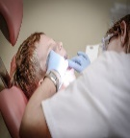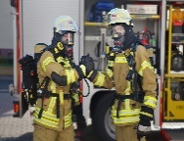  Dentist Firefighter Police |  | 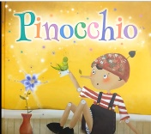 |  | 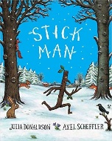  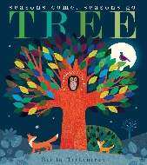
Scientific Enquiry |  | I can make observations over time  I know why we must brush our teeth.  I understand the roles of people who help us.  I can compare different materials.  I can look for similarities and differences in people’s appearance when describing.  I can identify patterns and prints. |  | I can identify and sort different materials.  I can identify and sort different materials.  I can compare how different materials react in water.  I can compare how different materials react in water. |  | I can identify each season.  I can observe a tree over time through the seasons.  I can use ID charts to find out about seasons.  I can identify each season and classify things in the correct season.  I can use the pictures from stories to help me learn about seasons.  I can identify and classify between different seasons
Working Scientifically |  | I can test out ideas to find out new things  I can explain why it is important to clean our teeth.  I can ask questions about why firefighters need to stay fit and healthy.  I can make basic predictions.  I can give detailed descriptions and record my results using pictures.  I can use my observation skills to solve problems. |  | I can draw pictures or spot different materials in my environment.  I can draw pictures or spot different materials in my environment.  I notice similarities and differences within the materials.  I notice similarities and differences within the materials. |  | I can draw pictures to explain what happens in each season.  I can make careful observations about the changes in the seasons.  I can explain what happens in each season  I can make simple predictions about which seasons things belong in.  I can ask questions to help my understanding  I can evaluate my learning and demonstrate my knowledge of seasons.
Ideas/WOW moments. | 1. Explore the job of a dentist, what does going to the dentist feel like and why do we need to look after our teeth? Children will conduct an experiment about the importance of brushing teeth.  2. Recap experiment from last time. Children will think more about why brushing their teeth is important.  3. Children to think about firefighters and what they do. How do they keep us safe? Why do fire fighters need to keep fit and healthy? Children are encouraged to be active and think about ways they exercise their muscles. Children to complete an assault course.  4. This lesson will focus on what a police officer does. Children will think about oxygen and how oxygen keeps fires alive. Children will be burning materials and observing closely.  5. This lesson focuses on what they should do in an emergency in terms of who to call and what to say to the operator, children should know their address and what is around them in their environment to help locate them.  6. Children will learn about the uniqueness of their finger prints and how they can be used to identify a person. Children will look closely at each other’s finger prints and try to identify who touches the coffee cup using their observation skills. |  | 1. Children have the opportunity to identify different materials. Children go on a material hunt to see if they can find the different materials in their environment.  2. Children will focus on the properties of different materials. Children will sort materials based on different properties.  3. This lesson will focus on how materials properties can change. Children to experience different changes in materials.  4. Children will be choosing appropriate materials to make a boat for Pinocchio. |  | 1. Pre learning about seasons. Discuss different seasons. Read Seasons book and watch what are the seasons? Ask children what they like to do in each season and children record their ideas.  2. Recap seasons. Children will think about the leaves on a tree in different seasons and the reasons for this. Children to decorate their tree in their favourite season using appropriate seasonal colours.  3. Children will go on a walk and identify things on the ID sheets, the walk will depend on the season you are learning this in- but advisable to repeat in each season.  4. This lesson will focus on weather and typical weather for each season. Children to match the weather with the season.  5. Children will be looking closely at leaves and will enjoy the story stick man. Children will create their own stick man and decorate to fit the season. Children will guess what season is their favourite.  6. Assessment of all learning and environmental activities.
Outcomes | - Can children identify the people that can help them?  - Can children identify ways to and why they need to keep their teeth clean?  - Can children identify what is needed to cause a fire and what to do in the event of one?  - Can children discuss the role of the fire service?  - Can children identify the skills/role of the police?  - Can children use observational skills for a purpose? |  | Can children identify different materials?  - Can children identify the properties of different materials?  - Can children identify the purposes of different materials?  - Can children begin to conduct simple experiments?  - Can children use materials for a purpose? |  | Children will understand that there are four seasons  -Children will be able to name the four seasons  -Children will be able to use some scientific words to describe their environment and link it to the season they are in.  -Children will be able to draw their own ideas about their own environment and things that they like to do in each season.  -Children will be able to describe the changes between each season and describe why some things belong in certain seasons.

