Science Knowledge and Skills Coverage. (Year 2)
IMPLEMENTATION
INTENT
Record results/ accurate measurements
Evaluate test
Content/  Knowledge | Animals Including Humans  I notice that animals including humans have offspring which grow into adults. I can find out about and describe the basic needs of animals including humans for survival. Describe the importance for humans of exercise, eating the right amounts of different types of food and hygiene |  |  |  | Living Things and Habitats  Explore and compare the differences between things that are living, dead and things that have never been alive. Identify most living things live in habitats to which they are suited and describe how different habitats provide for basic needs of different kinds of animals and plants and how the depend on each other. Identify and name a variety of plants and animals in their habitat, including microhabitats. Describe how animals obtain their food from plants and other animals, using the idea of a simple food chain and identify and name different sources of food. |  |  |  |  |  | Materials  To identify and compare the suitability of a variety of everyday materials including wood, metal, plastic, glass, brick, rock, paper, cardboard for particular uses. I can find out how the shape of solid objects made from materials can be changed by squashing, bending, twisting and stretching. |  |  |  | Plants  To observe and describe how seeds and bulbs grow into mature plants. Find and describe how plants need water, light and a suitable temperature to grow and stay healthy.
Book/ Science Capital | 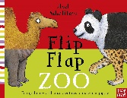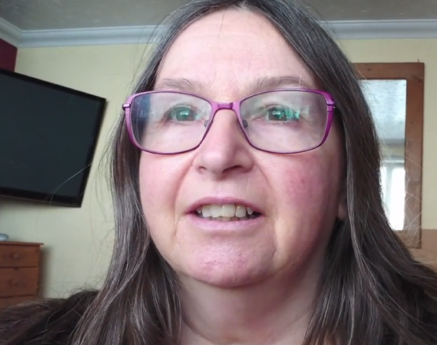  Health care assistant |  |  |  | - Mummy can I have a penguin story. |  |  |  |  |  | 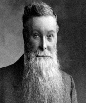  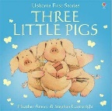  John Dunlop Oliver  Rackham |  |  |  | 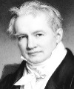  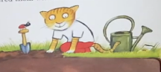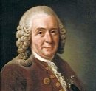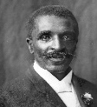  Sam plants a Carl Linnaeus George Alexander  Sunflower Washington Carver Von Humboldt  Identify and classify parts of a flower
Scientific Enquiry | Look for patterns in animals  Observe lifecycle over time  Research facts about animals | Identify and classify foods  Set up comparable test  Identify foods animals eat | Use research  Look for patterns in how germs spread  Identify and classify foods | Revise, research and recall  Observe over time |  | Identify and classify objects  Identify habitats  Research facts about animals |  |  |  | Look for patterns in data  Look for patterns in data  Find out what animals eat. |  | Compare and group materials.  Identify materials  Use research for understanding. |  | Comparative tests.  Notice patterns between materials.  Comparative test. | Identify plants using observations/identify plants in environment.  Use a Venn diagram to sort and classify  Observe over time how plants grow. | Look for patterns in my tests  Record observations after time  Carry out comparative test  Observe plants over time | Recap key concepts  Look for patterns  Use research  Look for patterns
Working Scientifically | Identify animals and offspring  Ask simple questions  Communicate findings | Sort food into groups and record  Plan and carry out test  Communicate findings about animals | Communicate using models  Make simple predictions  Use art to represent food groups | Answer questions using scientific knowledge.  Evaluate test |  | Ask questions  Draw basic conclusions  Record observations |  |  | Use tables and pictograms  Interpret results  Communicate findings |  |  | Identify and classify materials.  Labelled diagrams  Draw basic conclusions |  | Carry out simple comparative tests.  Predicting best material  Evaluate findings of tests | Identify plants using observations  Use a Venn diagram to sort and classify  Make observations on how a plant grows  Label parts of a flower | Carry out simple tests  Ask questions to investigate  Communicate clearly how plants grow  Make basic predictions | Evaluate learning  Observe plants in different climates
Ideas/WOW moments. | 1- Matching animals with offspring.  2- Lifecycles  3- Using IT to answer questions  4- Animal menus  5- Investigating which exercises raise pulse rate.  6- Investigating food groups and tasting foods.  Sort foods according to group.  7- Balanced diets, Links to art, children create art piece based on their food diaries.  8- Hygiene and medicines- investigation into why soap is important.  9 and 10- Children to design and create own microbe. Children to create their own soap or bath bomb.  11- germ investigation using bread.  12- Recap learning. |  |  |  | 1- Sort, living, dead and never been alive. Egg box material hunt.  2- Sorting animals according to its biome.  3- Exploring different biomes. Who am I clues?  Biome home learning  4- Micro habitats and mini beast hunting.  5- completing tables for extraordinary creatures. Creating own creature and habitat.  6- Food chain drama, draw food chains. |  |  |  |  |  | 1. Mystery bag. Make material monsters. Sort materials  2. Materials hunt.  3. Materials drama and modelling,  Silly materials.  4- comparing materials for 3 little pigs house.  5- Humpty dumpty investigation- make a protective sleeping bag using best material.  6- John Dunlop investigating bouncy materials. |  |  |  | 1. Identify parts of the plant- dice game.  2. Sam plants a sunflower book- lifecycle of a sunflower and strawberry.  3. Observing seeds and observational drawings. Classifying seeds.  4. Seed hunt and identifying seeds.  5. Conditions for growth, seeds from the kitchen  6. Investigation into plant growth using different soils.  7. Investigating bulbs and recording seed growth/germination.  8- Conditions for growth experiment- cress.  9. Evaluating test.  10. Plants in different climates, how do plants adapt to their environment?  11. Explore famous botanists. Outdoor learning- tree survey  12. Evaluate learning.
Cross curricular links/opportunities  IMPLEMENTATION | - History- Exploring scientists in the past  - Maths- reading tables and percentages.  - MFL- learn different foods in different languages.  - English- written evidence when interpreting evidence. Use scientific language.  - IT- Using search engines to find information. Use of videos to explain scientific content.  - PSHE- links to health and hygiene and how our bodies grow. Links to offspring and growing up. Links to drugs and medicines and how to keep our bodies healthy. Links to healthy eating.  - DT- Links to food technology to prepare foods using the food groups.  - Art- create own art piece using fruits- use artist Giuseppe Arcrimbolo. |  |  |  | - Geography- Exploring biomes around the world and climates.  - Maths- completing tables.  - DT- creating biomes.  - English- research and interpreting data. Written clues. Drama.  - Outdoor learning- mini beast hunting.  - IT- research, ID apps.  - MFL- learn animal names in different languages.  - Art- drawing own animals from interpreting data. |  |  |  |  |  | - English- developing asking questions, materials drama. Links to well known stories.  - ART/DT- Suitability of materials, making houses.  - IT- use of videos to support scientific learning.  - Maths- completing tables and reading data  - Outdoor learning- look at different surfaces outside.  - languages- introduce songs to support.  - PSHE- how to keep ourselves safe in the dark using reflectors.  - History- scientists from the past and history of tyres and roads. |  |  |  | - English- developing asking questions, links to growing stories, plant drama.  - Maths- sorting seeds using different criteria- Venn diagram. Collecting data in tables. Reading thermometers. Measuring.  - IT- use id apps and identification sheets.  - Art- careful pencil drawings of seeds using observation skills- adding detail.  - Geography- where do fruits come from.  - DT- Food technology- tasting cress and different fruits and vegetables.  - Geography- plants in different climates, how plants are adapted to different climates.
Resources needed to accompany the scheme | - Post it notes  - Flip flap zoo book (optional)  - Use of IT  - Pulse metre/data logger (optional)  - Sample of foods from each food group e.g. breads, cheese, lentil, fruit and vegetables, sweets or orange juice  - Range of packaging  - GloGerm gel (optional)  - Washing up bowls  - Pepper  - Washing up liquid  - Skewer/cocktail sticks  - Coloured plasticine  - Essential oils  - Optional bath bomb equip- baking soda, citric acid, corn flour, sea salt, coconut oil, water, food colouring.  - Bread  - Zip lock bags |  |  |  | - Post it notes  - Doll and puppet.  - Sorting hoops.  - Large leaves, water, grass (Astro turf) table lamp.  Sand, mini cactus, rocks, lamp  Frozen grass/mud or fake snow, ice. OR PICTURES printed from slides  - Plastic animals or pictures of animals from slides.  - Soil, grasses, shrubs, sand, lamp. Leaves, sticks, rocks, trees, gravel. Flocking grass/Astro turf, grasses, water, lamp.  - Mini beast equipment e.g. pooter, umbrella, sieve, petri dishes, viewing tanks, nets, magnifying glasses. |  |  |  |  |  | - Post it notes  - Range of materials and a bag (e.g. spoon, coin, fabric cap, woolly hat, paper, acorn, stone, peg)  - Range of resources from each category. E.g.  - Metal- aluminium foil, nuts, bolts, screws, coins, wire, paper clips, metal bottle tops, keys etc.  Wood- wooden lolly sticks, skewers, cocktail sticks, pegs, twigs, tree bark, wooden spoons, small pieces of wood.  Plastic- Plastic bags, cling film, bubble wrap, plastic cutlery, plastic packaging and bags, lego or duplo, cds, sequins, bottle tops.  Paper- writing paper, sugar paper, crepe paper, news paper, tissue paper, tracing paper, paper art straws, coloured sticky notes.  Fabric- wood, fur, leather, suede, voile, netting, denim and cotton.  - Plasticine  - Dice  - Three little pigs book (optional)  - Lollypop sticks, pasta, marshmallows, Lego or Polydron, cardboard, wooden bricks, paper cups, balsa wood etc.  - Materials- newspaper, cotton wool, polystyrene, sponge, water, tissue, fabric, bubble wrap. Zip lock bag  - Eggs.  - Reflective equipment to share if you have it.  - Ramp/strong card, Selection of balls |  |  |  | - Post it notes  - Dice  - Different seeds- acorns, conkers, sunflower, poppy, coriander, runner beans, kidney or mung beans, cress, sesame, coffee, brown rice, or coconut.  - Magnifying glasses  - Collection pots  - Plastic plant pots or cardboard planters.  - Soil, water, cocktail sticks (2 per group)  - Plastic cups, materials such as cotton wool, tissue, soil, toilet paper, stones and sand, cress seeds.  - Bulbs e.g. tulip, daffodil, hyacinth.  - Magnifying glasses.  - Seeds (Cress), planting pots/cups,  Soil, water, thermometers,  (air tight container if investigating no air)
 | Can sequence the stages of a baby. Observe these changes.  Can describe how animals change as they get older.  Develops understanding of how insects change (more than a butterfly) through lifecycle diagrams.  Can explain what humans and other animals need to survive.  Can describe how to keep clean and healthy.  Has a good understanding of the food plate and understands ‘a healthy balanced diet’.  Can adopt a menu to substitute food from the eat well plate.  Understands the effect of exercise on the body. |  |  |  | Find a range of items which are dead, living.  Can name plants/animals which live in different habitats and micro habitat.  Can talk about the features of the animal/plant and how they are suited to the habitat.  Can talk about what the animal eats.  Can construct a food chain using simple diagrams. |  |  |  |  |  | Can name an object, say what material it is made from, identify properties and make a link between property and use.  Whilst changing a shape of an object can describe the actions used.  Can use suitable vocabulary.  Simple tests relevant to properties.  Describe similarities and differences in materials. |  |  |  | Can describe how plants that have grown from seeds and bulbs have developed over time.  Can identify plants that grew well in different conditions.  Can spot similarities and differences between bulbs and seeds.  Can nurture seeds and bulbs into mature plants identifying the different requirements of different plants.
IMPACT

