Highfields Academy
Literacy Information Leaflet
Year 2
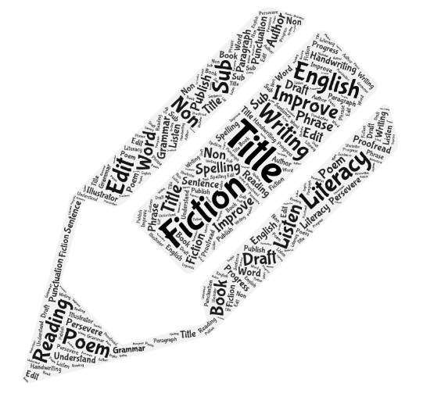
Year 2 End of Year Expectations

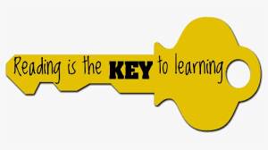
Reading
Word Reading
- Continue to apply phonic knowledge and skills as the route to decode words until automatic decoding has become embedded and reading is fluent
- Read accurately by blending the sounds in words that contain the graphemes taught so far, especially recognising alternative sounds for graphemes
- Read accurately words of two or more syllables that contain the same graphemes as above
- Read words containing common exception words, noting unusual correspondences between spelling and sound and where these occur in the word
- Read most words quickly and accurately, without overt sounding and blending, when they have been frequently encountered
- Read aloud books closely matched to their improving phonic knowledge, sounding out unfamiliar words accurately, automatically and without undue hesitation
- Reread these books to build up fluency and confidence in word reading
Comprehension
Develop pleasure in reading, motivation to read, vocabulary and understanding by:
- Listening to, discussing and expressing views about a wide range of contemporary and classic poetry, stories and non-fiction at a level beyond that at which they can read independently
- Discussing the sequence of events in books and how items of information are related
- Becoming increasingly familiar with and retelling a wider range of stories, fairy stories and traditional tales
- Being introduced to non-fiction books that are structured in different ways
- Recognising simple recurring literary language in stories and poetry
- Discussing and clarifying the meanings of words, linking new meanings to known vocabulary
- Discussing their favourite words and phrases
- Continuing to build up a repertoire of poems learned by heart, appreciating these and reciting some, with appropriate intonation to the make the meaning clear
- Having regular opportunities to Read for Pleasure
- Understand both the books they can already read accurately and fluently, and those that they listen to by:
- Drawing on what they already know or on background information and vocabulary provided
- Checking that the text makes sense to them as they read, and correcting inaccurate reading
- Making inferences on the basis of what is being said and done
- Answering and asking questions and predicting what might happen on the basis of what has been read so far
- Participate in discussion about books, poems and other words that are read to them and those that they can read for themselves; taking turns and listening to what others have to say
- Explain and discuss their understanding of books, poems and other material, both that they listen to and those that they read for themselves
Year 2 End of Year Expectations
Writing
Transcription
Spell by:
- Segmenting spoken words into phonemes and representing these by graphemes, spelling many correctly
- Learning new ways of spelling phonemes for which one or more spellings are already known, and learn some words with each spelling, including a few common homophones
- Learning to spell common exception words
- Learning to spell more words with contracted forms
- Learning the possessive apostrophe (singular) e.g. the girl’s book
- Distinguishing between regularly used homophones and near-homophones
- Add suffices to spelling longer words including -ment, -ness, -ful, -less, -ly
- Write from memory simple sentences dictated by the teacher that include words used the GPCs, common exception words and punctuation taught so far
Composition
Develop positive attitudes and stamina for writing by:
- Writing narratives about personal experiences and those of others (real and fictional)
- Writing about real events
- Writing poetry
- Writing for different purposes
Consider what they are going to write before beginning by:
- Planning or saying out loud what they are going to write about
- Writing down ideas and/or key words, including new vocabulary
- Encapsulating what they want to say, sentence by sentence
Make simple addition, revisions and corrections to their own writing by:
- Evaluating their writing with the teacher and other pupils
- Rereading to check that their writing makes sense
- Check that verbs to indicate time are used correctly and consistently, including verbs in the continuous form e.g. I am swimming, He is having dinner
- Proofreading to check for errors in spelling, grammar and punctuation
- Read aloud what they have written with appropriate intonation to make meaning clear

Year 2 Grammar and Terminology
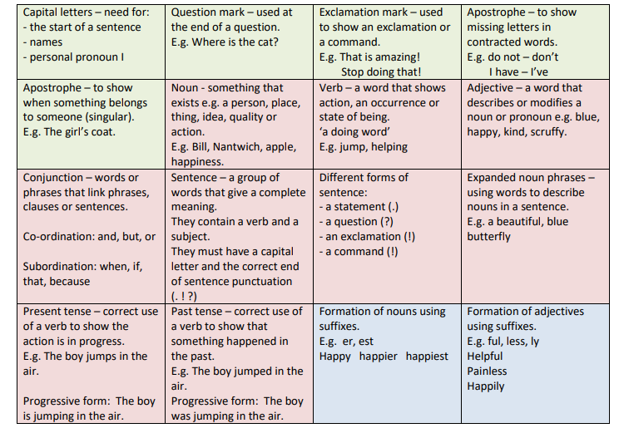
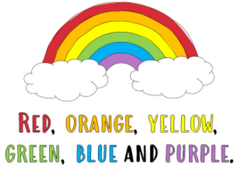

Year 2 Common Exception Words
By the end of Year 2, children should be able to spell these words correctly and use them in their independent writing appropriately.
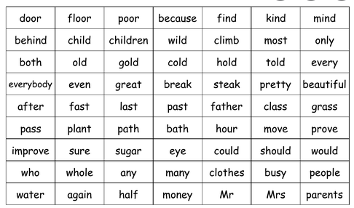
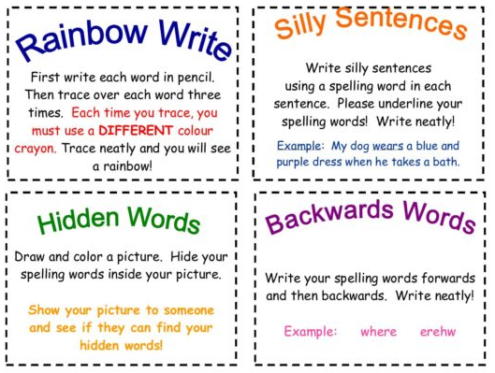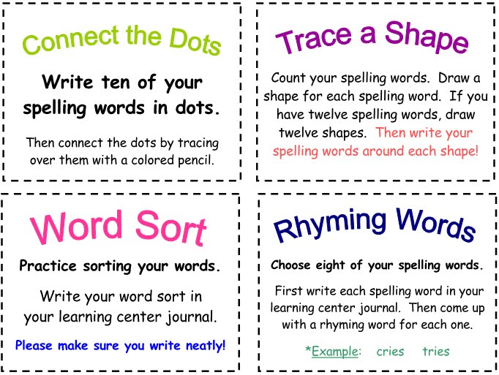
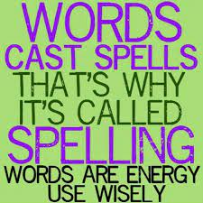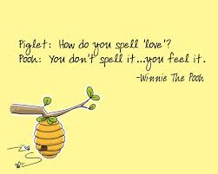
Handwriting expectations in Year 2
Pupils should be taught to:
- Form lower-case letters of the correct size relative to one another
- Start using some of the diagonal and horizontal strokes needed to join letters and understand which letters, when adjacent to one another, are best left unjoined
- Write capital letters and digits of the correct size, orientation and relationship to one another and to lower-case letters
- Use spacing between words that reflects the size of the letters
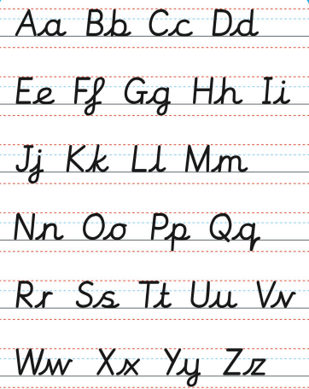

Supporting your child at home
Reading Regularly listen to your child read (at least three times a week but daily if possible). This will help them to become fluent readers. Read to them! This will help your child to understand appropriate pace and expression. Take turns talking about the book your are reading. Show your child that reading can be fun by making books a part of their daily life.
Questions to support your child’s understanding:
- What feelings did you have as you read the story? Why?
- What kind of person is this character? How do you know?
- Prediction what you think will happen next and why.
- Does this story remind you of another you have read? How?
- Tell me about the story so far.
- Are you enjoying this book? Why?
Writing Writing should always have a purpose and be fun. There are lots of different ways you can encourage your children to practise their writing. For example:
- Keeping a holiday diary
- Write thank you letters
- Send postcards
- Write shopping lists
- Writing short stories
Always get your child to read back their writing to you out loud. This way it will be much easier for them to sport mistakes and find ways to improve their work. Ensure that your child is writing neatly and legibly (see the Handwriting guidance).
Word Games These can really help your child to build their vocabulary and increase their working memory for words.
- My Basket - each time you add an extra item to the basket. E.g. In my basket there is a loaf of bread. In my basket there is a loaf of bread and a bottle of milk. Etc.
- My grandmother’s cat – take turns adding adjectives to describe the cat e.g. fluffy, grey, grumpy, vicious, sneaky. You can change grandmother’s pet!
- How many words – think of as many words as possible to describe a person, place, building, food, toy, animal etc.
- Something starting with … - how many words can you think of that starts with your chosen letter?
- Turn-taking story – one person starts a story and you keep taking turns to add to the story.
Spelling Reading really improves spelling as children are regularly seeing words spelled correctly and are then able to spot when something ‘doesn’t look right’. When learning words, regular five minute blasts in much more effective that one long session – little and often really is the key. Finally, practise spellings in lots of different ways – see examples on the spelling page.

Useful websites, apps and resources
NB: Some of these are free and some require a subscription.
https://www.bbc.co.uk/bitesize/subjects/zgkw2hv
http://www.crickweb.co.uk/ks1literacy.html
https://www.topmarks.co.uk/interactive.aspx?cat=43
http://www.primaryhomeworkhelp.co.uk/literacy/
https://www.ictgames.com/mobilePage/literacy.html
https://www.everyschool.co.uk/english-key-stage-1-words.html
https://www.bbc.co.uk/games/embed/small-town-superheroes
Android and Apple also have a wide range of learning apps for you to access. Here is a selection of some well-known ones but they are constantly changing and expanding.
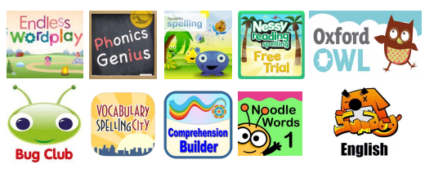
Finally, there are lots of practise books that you can buy from places such as WHSmith and Amazon. If you search online for Year 2 worksheets, there are also many free resources available.

