Highfields Academy
Literacy Information Leaflet
Year 4
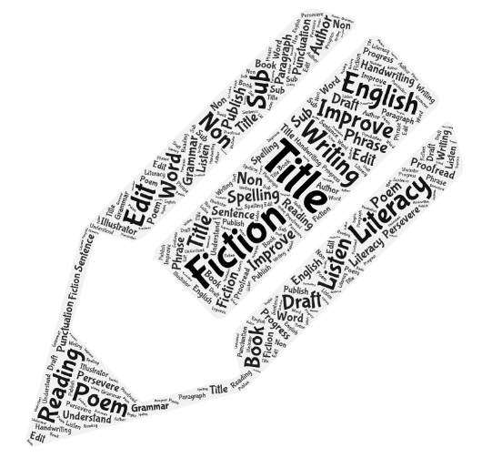
Year 4 End of Year Expectations

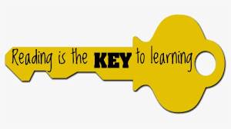
Reading
Word Reading
- Apply knowledge of root words, prefixes and suffixes to read aloud and to understand the meaning of unfamiliar words
- Read further exception words, noting the unusual correspondences between spelling and sound, and where these occur in the world
- Attempt pronunciation of unfamiliar words drawing on prior knowledge of similar looking words
- Read age appropriate books with confidence and fluency

Comprehension
- Know which books to select for specific purposes e.g. science, history, geography learning
- Use dictionaries to check the meaning of unfamiliar words
- Know and recognise some of the literary conventions in text types covered
- Begin to understand simple themes in books
- Explain why text types of organised in a certain way
- Identify some text types organisational features for different genres e.g. narrative, explanation, persuasion
- Explain the meaning of words in context
- Identify how the writer has used precise word choices for effect
- Discuss and record words and phrases that the writer uses to engage and impact upon the reader
- Retrieve and record information from non-fiction and fiction texts
- Infer meanings and begin to justify them with evidence from the text
- Predict what might happen from details stated and deduced information
- Begin to build on own and others’ ideas and opinions about a text in discussion
- Make connections with prior knowledge of books/texts and experience
- Prepare poems to read aloud and to perform, showing understanding through the use of intonation, tone, volume and action

End of Year Expectations
Writing
Transcription
- Spelling words with additional prefixes and suffixes and understand how to add them to root words
- Recognise and spell frequently used homophones
- Use the first two or three letters of a word to check its spelling in a dictionary
- Spelling identified commonly misspelt words from the Year 3/4 word list
- Use the diagonal and horizontal strokes that are needed to join letters
- Understand which letters, when adjacent to one another, are best left unjoined
- Increase the legibility, consistency and quality of their handwriting including the size and orientation of letters, and the clear use of ascenders and descenders
Composition
- Compose sentences using a wider range of structures – linked to the grammar objectives
- Orally rehearse structures sentences or sequences of sentences
- Begin to open paragraphs with topic sentences
- Write a narrative with a clear structure, setting, characters and plot
- Use a range of sentences with more that one clause (extending to use fronted and/or embedded clauses)
- Use appropriate nouns and pronouns to avoid repetition in a piece of work and to support cohesion
- Use fronted adverbials to create variety with sentence openers e.g. Later that day, Cautiously, Crouching behind the wall,
- Use expanded noun phrases with modifying adjectives and prepositional phrases e.g. The strict maths teachers with the curly hair
- Make improvements by proposing changes to grammar and vocabulary
- Proofread and edit the spelling and punctuation within a piece of writing
- When writing speech sentences, use other punctuation including a comma after the reporting clause
- Use paragraphs to show a change of time, place, person or topic/idea
- Use apostrophes to show possession – singular and plural
- Use a comma after a fronted adverbial

Year 4 Grammar and Terminology
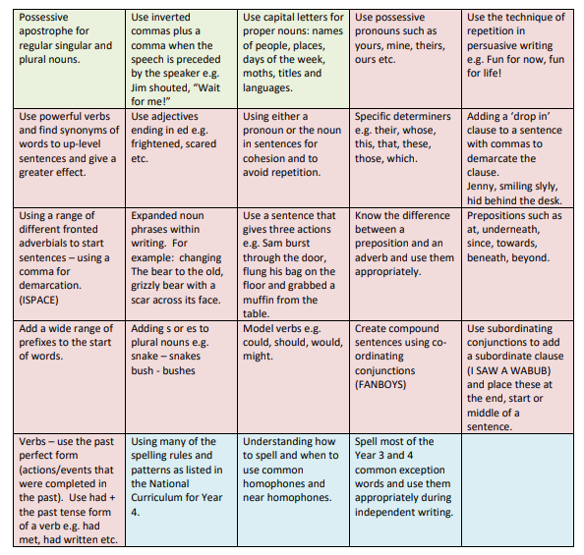
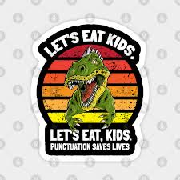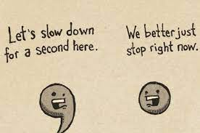
Year 4 Common Exception Words – most of these should be spelled correctly and used appropriately.
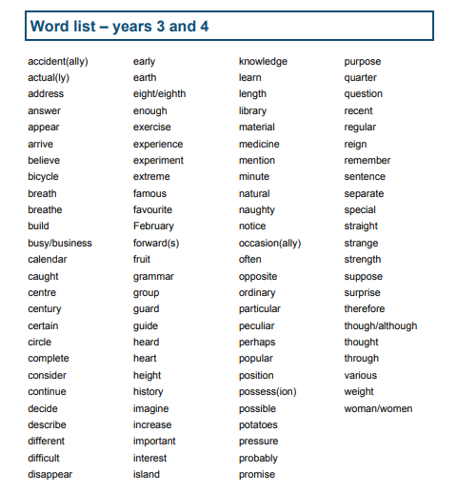
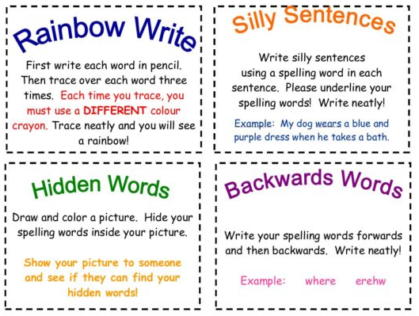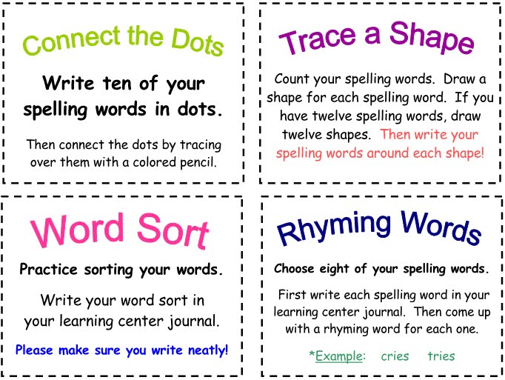
Handwriting expectations in Year 4
Children will be expected to write in joined cursive handwriting with a pen (for a final copy of a piece of writing). In addition, they should be able to show capital letters, ascenders and descenders clearly, and used appropriate sizing and spacing in their work. Short bursts of writing in the most effective way to build a fluent and legible joined style of writing.
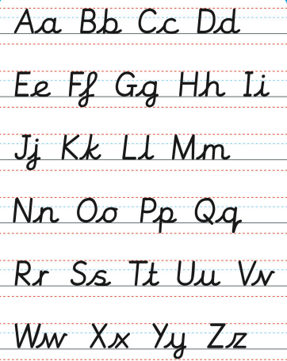

Supporting your child at home
Reading Encourage your children to read a variety of books by different authors and to expand their reading to include other types of text e.g. newspapers, magazines, poetry, play scripts, leaflets etc. Remember, the local library has lots of resources for free!
Questions to support your child’s understanding:
- What feelings did you have as you read the story? Why?
- What kind of person is this character? How do you know?
- Prediction what you think will happen next and why.
- Does this story remind you of another you have read? How?
- Tell me about the story so far.
- Are you enjoying this book? Why?
Writing Writing should always have a purpose and be fun. There are lots of different ways you can encourage your children to practise their writing. For example:
- Keep a holiday diary
- Write thank you letters
- Send postcards
- Write shopping lists
- Write creative short stories
- Do they want something? Write a persuasive speech.
- Use computers and tablets to create stories, fact files, comic etc.
Always get your child to read back their writing to you out loud. This way it will be much easier for them to sport mistakes and find ways to improve their work. Also provide a dictionary for them to check unfamiliar or tricky words. Finally, ensure that your child is writing using joined writing that is legible.
Spelling Reading really improves spelling as children are regularly seeing words spelled correctly and are then able to spot when something ‘doesn’t look right’. When learning words, regular five minute blasts in much more effective that one long session – little and often really is the key. Finally, practise spellings in lots of different ways – see examples on the spelling page.

Useful websites, apps and resources
NB: Some of these are free and some require a subscription.
https://www.bbc.co.uk/bitesize/subjects/zv48q6f
https://www.twinkl.co.uk/resources/twinkl-go/ks2-twinkl-go/english-ks2-twinkl-go
http://www.crickweb.co.uk/ks2literacy.html
http://www.primaryhomeworkhelp.co.uk/literacy/
https://www.topmarks.co.uk/english-games/7-11-years/spelling-and-grammar
Android and Apple also have a wide range of learning apps for you to access. Here is a selection of some well-known ones but they are constantly changing and expanding.
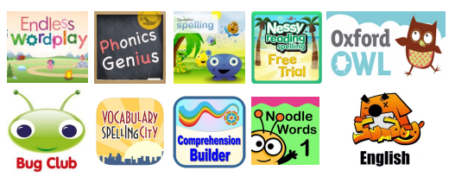
Finally, there are lots of practise books that you can buy from places such as WHSmith and Amazon. If you search online for Year 4 worksheets, there are also many free resources available.

