Highfields Academy
Literacy Information Leaflet
Year 6
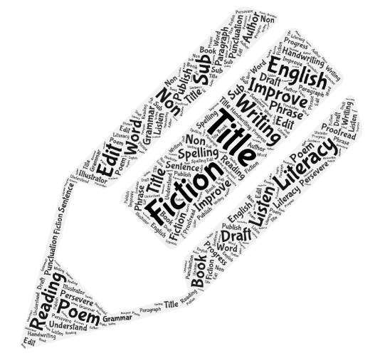
Year 6 End of Year Expectations

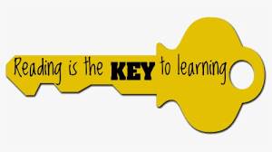
Reading
Word Reading
- Apply their growing knowledge of root words, prefixes and suffixes (morphology and etymology), as listed in English Appendix 1, both to read aloud and to understand the meaning of new words that they meet.
Comprehension
Maintain positive attitudes to reading and an understanding of what they read by:
- Continuing to read and discuss an increasingly wide range of fiction, poetry, plays, non-fiction and reference books or text books
- Reading books that are structured in different ways and reading for a range of purposes
- Increasing their familiarity with a wide range of books, including myths, legends and traditional stories, modern fiction, fiction from our literary heritage, and books from other cultures and traditions
- Recommending books that they have read to their peers, giving reasons for their choices
- Identifying and discussion themes and convention in and across a wide range of writing
- Making comparisons within and across books
- Learning a wider range of poetry by heart
- Preparing poems and plays to read aloud and to perform, showing understanding through intonation, tone and volume so that the meaning is clear to an audience
Understand what they read by:
- Checking that the book makes sense to them, discussing their understanding and exploring the meaning of words in context
- Asking questions to improve their understanding
- Drawing inference about characters’ feelings, thoughts and motive from their action, and justifying inference with evidence from the text
- Prediction what might happen from details stated and implied
- Summarising the main ideas from more than one paragraph, identifying key details that support the main ideas
- Identifying how language, structure and presentation contribute to meaning
- Discuss and evaluate how authors use language, including figurative language, considering the impact on the reader
- Distinguish between statements of fact and opinion
- Retrieve, record and present information from non-fiction texts
- Participate in discussions about books that are read to them and those that they read for themselves, building on their own and others’ ideas and challenging views courteously
- Explain and discuss their understanding of what they have read, including through formal presentations and debates, maintaining a focus on the topic and using notes provide reasoned justifications for their views
Year 6 End of Year Expectations
Writing
Transcription
- Use further prefixes and suffixes and understand the guidance for adding them
- Spell some words with silent letters e.g. knight, psalm, solemn
- Continue to distinguish between homophones and other words which are often confused
- Use knowledge of morphology and etymology in spelling and understand that the spelling of some words needs to be learnt specifically
- Use the first 3 or 4 letters of a word to check spelling, meaning or both using a dictionary
- Use a thesaurus to find alternative words
Composition
Plan their writing by:
- Identifying the audience and purpose of the writing, selecting the appropriate form and using other similar writing as models for their own
- Noting and developing initial ideas, drawing on reading and research where necessary
- In writing narratives, considering how authors have developed characters and settings in what pupils have read, listened to or seen performed
Draft and write by:
- Selecting appropriate grammar and vocabulary, understanding how such choices can change and enhance meaning
- In narratives, describing settings, characters and atmosphere and integrating dialogue to convey character and advance the action
- Precising longer passages
- Using a wide range of devices to build cohesion within and across paragraphs
- Using further organisational and presentational devices to structure text and to guide the reader e.g. subheadings, bullet points, underlining
Evaluate and edit by:
- Assessing the effectiveness of their own and others’ writing
- Proposing changes to vocabulary, grammar and punctuation to enhance effect and clarify meaning
- Ensuring the consistence and correct use of tense throughout a piece of writing
- Ensuring correct subject and verb agreement when using singular and plural, distinguishing between the language of speech and writing and choosing the appropriate register
- Proofread for spelling and punctuation errors
- Perform their own compositions, using appropriate intonation, volume and movement so that meaning is clear

Year 6 Grammar and Terminology
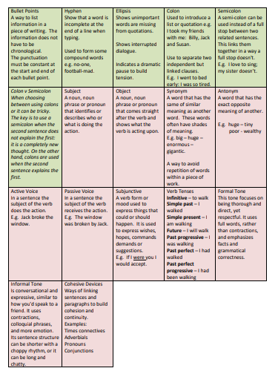
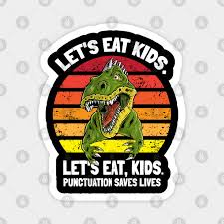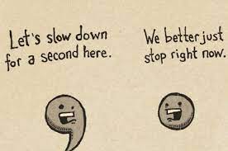
Year 6 Common Exception Words – most of these should be spelled correctly and used appropriately.
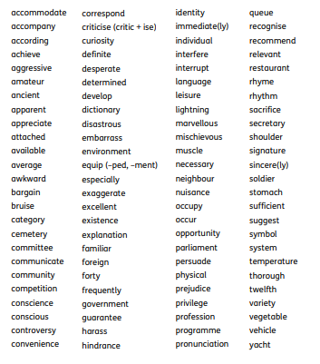
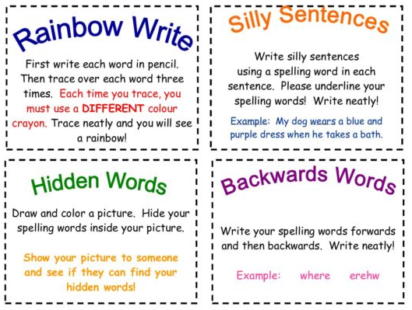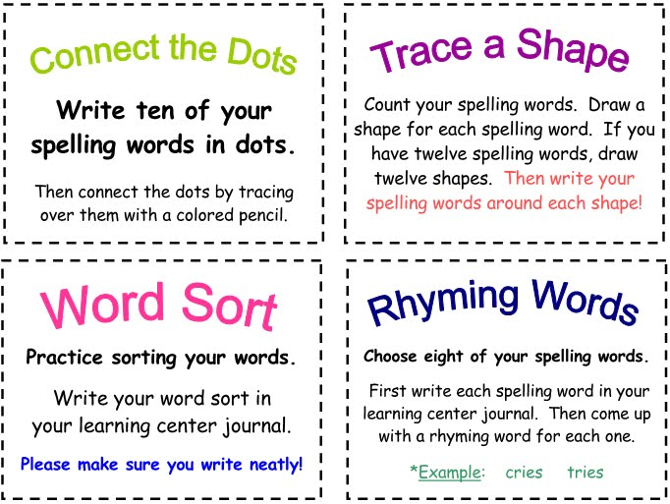
Handwriting expectations in Year 6
Children will be expected to write in joined cursive handwriting with a pen (for a final copy of a piece of writing). In addition, they should be able to show capital letters, ascenders and descenders clearly, and used appropriate sizing and spacing in their work. Short bursts of writing in the most effective way to build a fluent and legible joined style of writing.
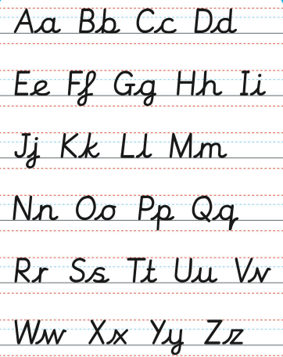

Supporting your child at home
Reading Encourage your children to read a variety of books by different authors and to expand their reading to include other types of text e.g. newspapers, magazines, poetry, play scripts, leaflets etc. Remember, the local library has lots of resources for free!
Questions to support your child’s understanding:
- What feelings do you have as you read the story? Why?
- What parts of the text do you like/dislike and why?
- How is the text laid out? It is similar or different to other things you have read?
- Is there any vocabulary you don’t understand? How could we find out what it means?
- What kind of person is the main character? How do you know?
- What do you think will happen next? What evidence is there to support your idea?
- Is this story like any other you have read? Explain how.
- Can you summarise what you have read?
Writing Children should be encouraged to write at home in a variety of ways. They need to ensure that the writing is purposeful and has a specific audience. For example:
- Diaries or thought bubbles about their day.
- A news article about an event.
- Creative stories based on myths, legends, fantasy, comedy etc.
- Instructions or guides for something they have made/created.
- Letters or postcards to friends or family members.
- Do they want something? Write a persuasive speech.
Always get your child to read back their writing to you out loud. This way it will be much easier for them to sport mistakes and find ways to improve their work. Also provide a dictionary for them to check unfamiliar or tricky words. Finally, ensure that your child is writing using joined writing that is legible.
Spelling Reading really improves spelling as children are regularly seeing words spelled correctly and are then able to spot when something ‘doesn’t look right’. When learning words, regular five minute blasts in much more effective that one long session – little and often really is the key. Finally, practise spellings in lots of different ways – see examples on the spelling page.
Punctuation and Grammar Look for errors and correct them before handing in a piece of work. Play online games to support learning.
Useful websites, apps and resources
NB: Some of these are free and some require a subscription.
https://www.bbc.co.uk/bitesize/subjects/zv48q6f
https://www.twinkl.co.uk/resources/twinkl-go/ks2-twinkl-go/english-ks2-twinkl-go
http://www.crickweb.co.uk/ks2literacy.html
http://www.primaryhomeworkhelp.co.uk/literacy/
https://www.topmarks.co.uk/english-games/7-11-years/spelling-and-grammar
Android and Apple also have a wide range of learning apps for you to access. Here is a selection of some well-known ones but they are constantly changing and expanding.
Finally, there are lots of practise books that you can buy from places such as WHSmith and Amazon.
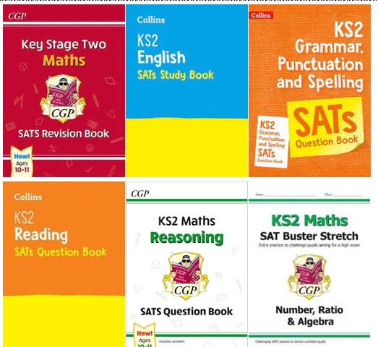
If you search online for Year 6 worksheets, there are also many free resources available.

