Highfields Academy
Literacy Information Leaflet
Reception (EYFS)
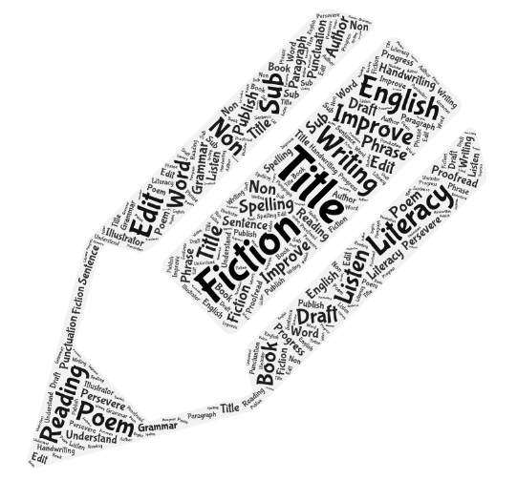
EYFS End of Year Expectations
Communication and Language
Listening, Attention and Understanding
Children at the expected level of development will:
- Listen attentively and respond to what they hear with relevant questions, comments and actions when being read to and during whole class discussions and small group interactions;
- Make comments about what they have heard and ask questions to clarify their understanding;
- Hold conversation when engaged in back-and-forth exchanges with their teacher and peers.
Speaking
Children at the expected level of development will:
- Participate in small group, class and one-to-one discussions, offering their own ideas, using recently introduced vocabulary;
- Offer explanations for why things might happen, making use of recently introduced vocabulary from stories, non-fiction, rhymes and poems when appropriate;
- Express their ideas and feelings about their experiences using full sentences, including use of past, present and future tenses and making use of conjunctions, with modelling and support from their teacher.

Comprehension
Children at the expected level of development will:
- Demonstrate understanding of what has been read to them by retelling stories and narratives using their own words and recently introduced vocabulary;
- Anticipate – where appropriate – key events in stories;
- Use and understand recently introduced vocabulary during discussions about stories, non-fiction, rhymes and poems and during role-play.
Word Reading
Children at the expected level of development will:
- Say a sound for each letter in the alphabet and at least 10 digraphs;
- Read words consistent with their phonic knowledge by sound-blending;
- Read aloud simple sentences and books that are consistent with their phonic knowledge, including some common exception words.
Writing
Children at the expected level of development will:
- Write recognisable letters, most of which are correctly formed;
- Spell words by identifying sounds in them and representing the sounds with a letter or letters;
- Write simple phrases and sentences that can be read by others.

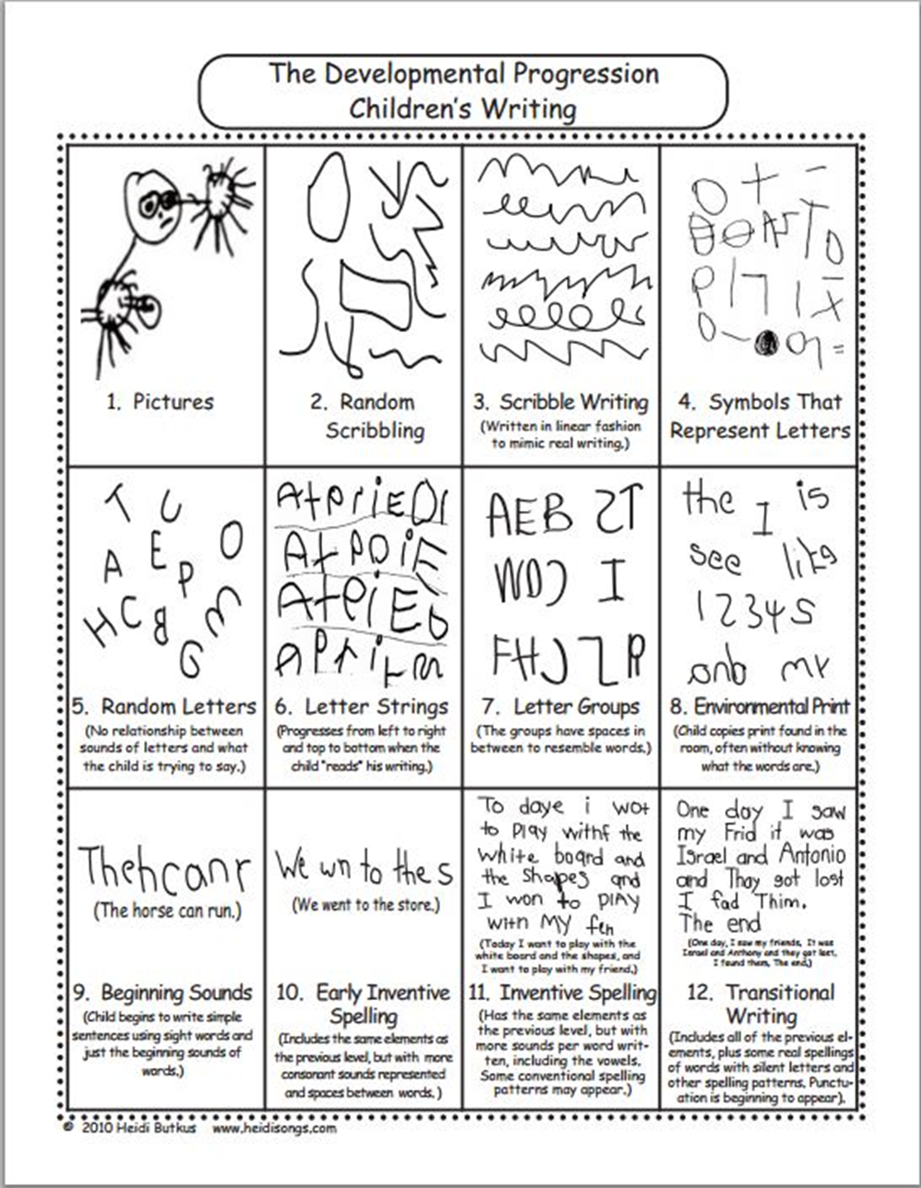

EYFS Phonics and High Frequency Words
We follow the Little Wandle Letters and Sounds systematic synthetic phonics scheme and these are the graphemes taught in EYFS.
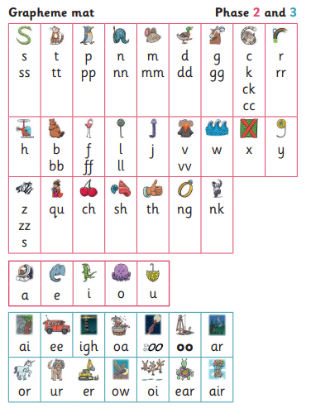
These are the ‘tricky’ words covered in EYFS (they are split into the Autumn, Spring and Summer terms).
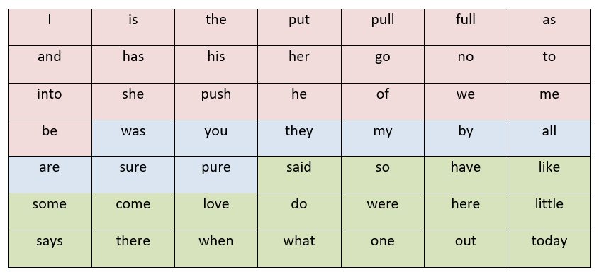
Handwriting expectations in EYFS
The children are taught to form their letters using a non-cursive style.
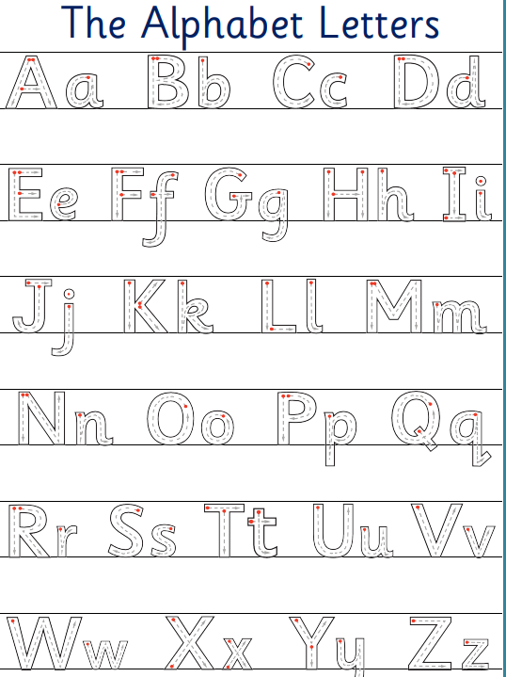
Fine Motor Skills
Children at the expected level of development will:
Hold a pencil effectively in preparation for fluent writing – using the tripod grip in almost all cases.

Supporting your child at home
Reading
- Read a variety of books and other types of text e.g. cook books, shopping lists, leaflets etc.
- Read stories to your child regularly – discuss what you have read.
- Identify sounds and familiar words in texts.
- Visit the local library and encourage your child to choose books that appeal to them.
Writing
- Messy play tray to help with letter formation and writing simple words.
- Magnetic letters to practise spellings familiar words.
- Write for different purposes e.g. lists, postcards, thank you notes.
- Encourage your child to read back what they have written.
Ways to develop fine motor skills
- Playdough
- Elastic bands over different objects
- Picking up objects with tweezers
- Threading, weaving and lacing in different ways
- Unlocking padlocks using keys
- Small construction toys e.g. Lego
- Jigsaw puzzles
- Cutting with scissors
- Tracing over patterns
- Water play
- Gardening and planting
- Cooking (with an adult!)

Useful Websites
https://www.busythings.co.uk/
http://www.bbc.co.uk/cbeebies
http://www.bbc.co.uk/schools/websites/eyfs/
http://www.bbc.co.uk/cbeebies/stories
http://www.funwithspot.com/
http://www.crickweb.co.uk/Early-Years.html
http://www.britishcouncil.org/kids-songs-little-kids.htm
Ideas for toys/resources to support early Literacy skills
